Mineral Titles Act
NOTICE OF GRANT OF A MINERAL TITLE
Title Type and Number: | Extractive Mineral Exploration Licence 33624
Granted: | 29 January 2024, for a period of 2 Years
Area: | 2 Blocks, 1.63 km²
Locality: | KATHERINE
Name of Holder/s: | 100% HARBROW MINING EQUIPMENT PTY LTD [ACN. 636 421 942]
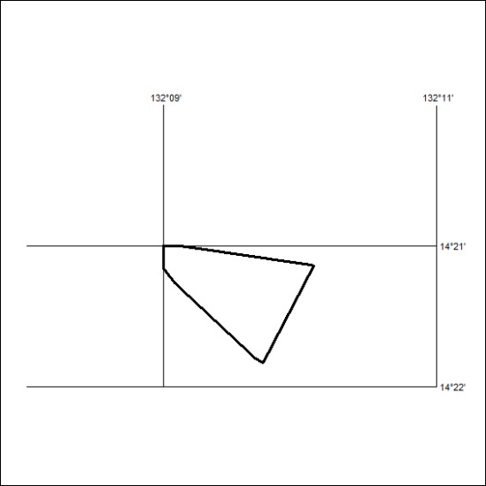
Area granted is indicated above. The titleholder is not permitted to exercise occupational rights on any land that is subject to a development title, or an application for a development title. Any land the subject of a Reserved Land gazettal under the Mineral Titles Act and all land vested in the Commonwealth of Australia is also excluded by description but not excised from the grant area.

24/24

