Mineral Titles Act
NOTICE OF GRANT OF A MINERAL TITLE
Title Type and Number: | Mineral Lease 33020
Granted: | 08 December 2023, for a period of 10 Years
Area: | 205.90 Hectares
Locality: | McKINLAY RIVER
Name of Holder/s: | 100% GMG MINING (NT) PTY LTD [ACN. 634 618 410]
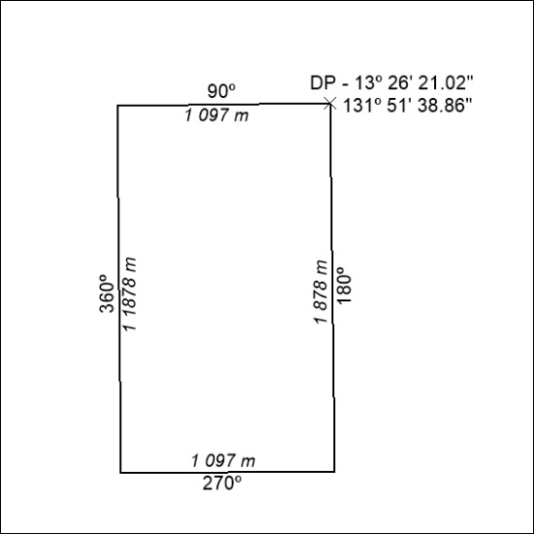

506/23

