Mineral Titles Act 2010
NOTICE OF LAND CEASING TO BE A MINERAL TITLE APPLICATION AREA
Title Type and Number: | Exploration Licence 33526
Area Ceased on: | 17 November 2023
Area: | 54 Blocks, 157.75 km²
Locality: | RIDDOCH
Name of Applicant(s)/Holder(s): | 100% SANDFIRE RESOURCES LIMITED* [ACN. 105 154 185]
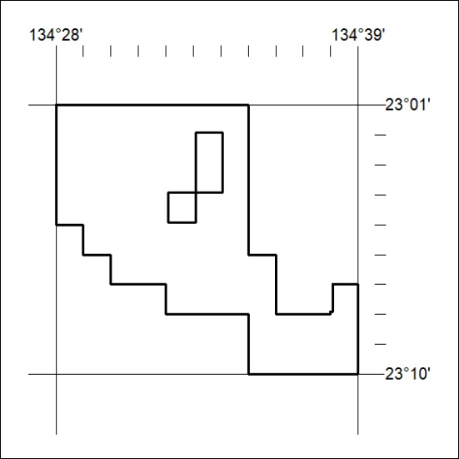

479/23

Mineral Titles Act 2010
NOTICE OF LAND CEASING TO BE A MINERAL TITLE APPLICATION AREA
Title Type and Number: | Exploration Licence 33527
Area Ceased on: | 17 November 2023
Area: | 54 Blocks, 157.75 km²
Locality: | RIDDOCH
Name of Applicant(s)/Holder(s): | 100% WILUNA WEST GOLD PTY LTD [ACN. 116 550 111]

480/23

Mineral Titles Act 2010
NOTICE OF LAND CEASING TO BE A MINERAL TITLE APPLICATION AREA
Title Type and Number: | Exploration Licence 33529
Area Ceased on: | 17 November 2023
Area: | 35 Blocks, 101.59 km²
Locality: | RIDDOCH
Name of Applicant(s)/Holder(s): | 100% GEMPART (NT) PTY LTD* [ACN. 081 859 896]
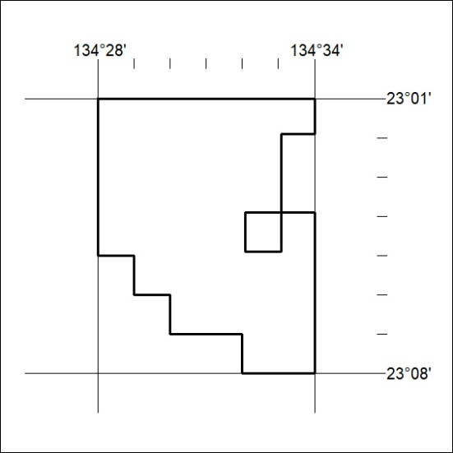

481/23

Mineral Titles Act 2010
NOTICE OF LAND CEASING TO BE A MINERAL TITLE APPLICATION AREA
Title Type and Number: | Exploration Licence 33530
Area Ceased on: | 17 November 2023
Area: | 50 Blocks, 156.54 km²
Locality: | RIDDOCH
Name of Applicant(s)/Holder(s): | 100% IGO NEWSEARCH PTY LTD [ACN. 142 192 701]
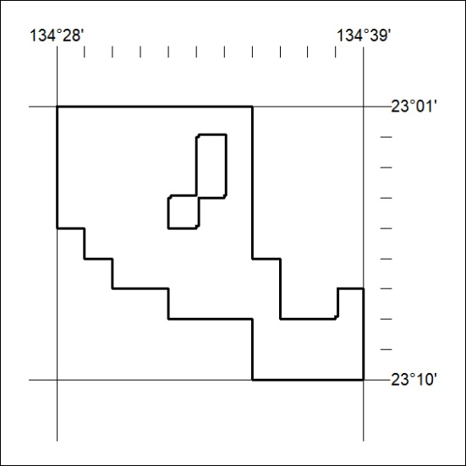

482/23

