Mineral Titles Act
NOTICE OF GRANT OF A MINERAL TITLE
Title Type and Number: | Extractive Mineral Lease 33497
Granted: | 25 October 2023, for a period of 10 Years
Area: | 99.58 Hectares
Locality: | REYNOLDS RIVER
Name of Holder/s: | 100% COOMALIE COMMUNITY GOVERNMENT COUNCIL
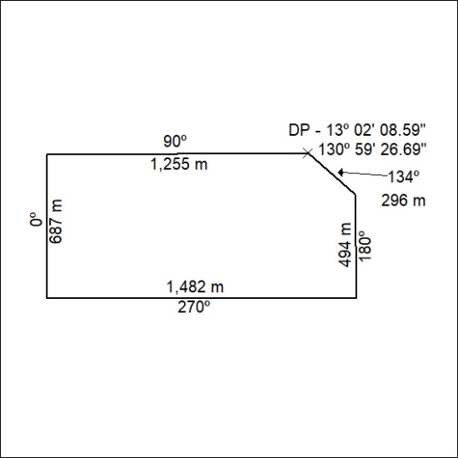

447/23

