Mineral Titles Act 2010
NOTICE OF LAND CEASING TO BE A MINERAL TITLE AREA
Title Type and Number: | Exploration Licence 31013
Area Ceased on: | 16 August 2023
Area: | 17 Blocks, 55.77 km²
Locality: | LANCEWOOD
Name of Applicant(s)/Holder(s): | 100% SCRIVEN EXPLORATION PTY LTD [ACN. 006 264 615]
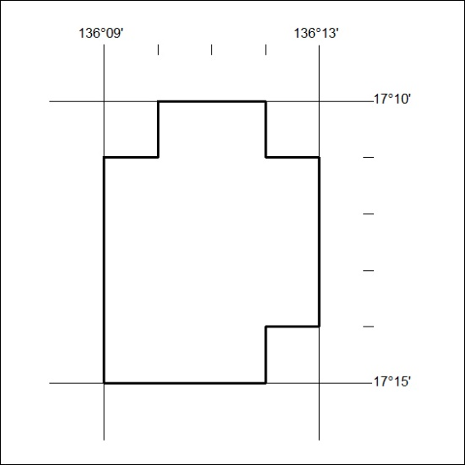

346/23

Mineral Titles Act 2010
NOTICE OF LAND CEASING TO BE A MINERAL TITLE AREA
Title Type and Number: | Exploration Licence 32066
Area Ceased on: | 16 August 2023
Area: | 35 Blocks, 115.05 km²
Locality: | MALLAPUNYAH
Name of Applicant(s)/Holder(s): | 100% SCRIVEN EXPLORATION PTY LTD [ACN. 006 264 615]
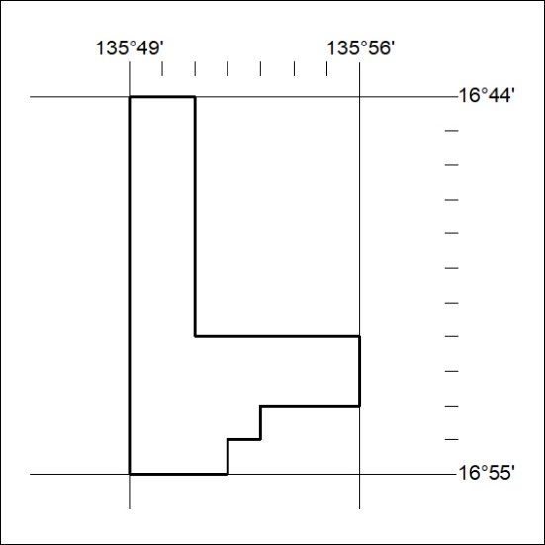

347/23

