Mineral Titles Act 2010
NOTICE OF LAND CEASING TO BE A MINERAL TITLE AREA
Title Type and Number: | Exploration Licence 32106
Area Ceased on: | 14 August 2023
Area: | 93 Blocks, 304.81 km²
Locality: | KILGOUR
Name of Applicant(s)/Holder(s): | 100% RIO TINTO EXPLORATION PTY LIMITED [ACN. 000 057 125]
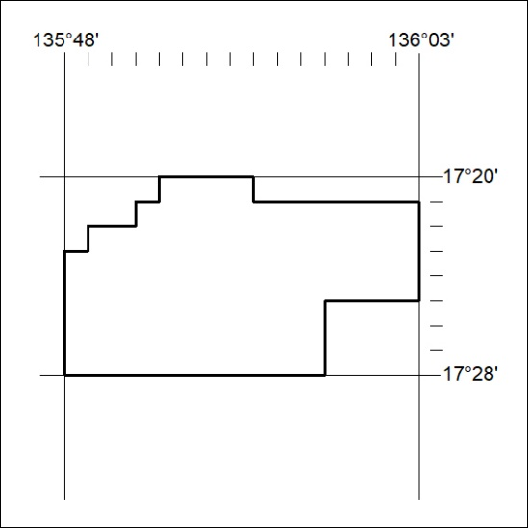

343/23

