Mineral Titles Act 2010
NOTICE OF LAND CEASING TO BE A MINERAL TITLE AREA
Title Type and Number: | Exploration Licence 32306
Area Ceased on: | 18 May 2023
Area: | 39 Blocks, 126.32 km²
Locality: | ALROY
Name of Applicant(s)/Holder(s): | 100% STRATEGIC ENERGY RESOURCES LIMITED* [ACN. 051 212 429]
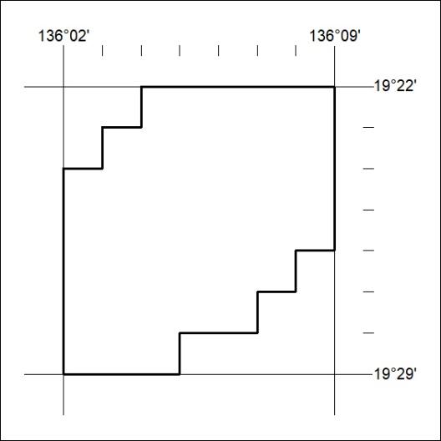
Area now amalgamated into Exploration Licence 33507 under s102 – EL moratorium period does not apply

157/23

Mineral Titles Act 2010
NOTICE OF LAND CEASING TO BE A MINERAL TITLE AREA
Title Type and Number: | Exploration Licence 32809
Area Ceased on: | 18 May 2023
Area: | 4 Blocks, 12.95 km²
Locality: | WONARAH
Name of Applicant(s)/Holder(s): | 100% STRATEGIC ENERGY RESOURCES LIMITED* [ACN. 051 212 429]
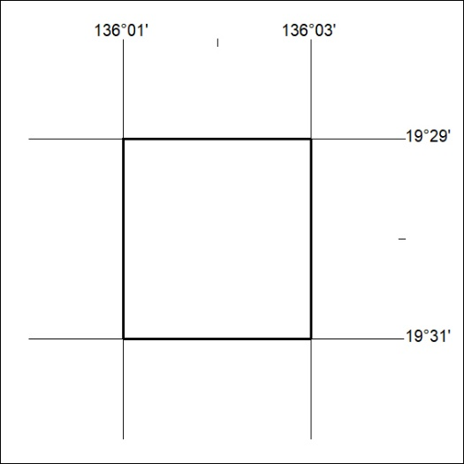
Area now amalgamated into Exploration Licence 33507 under s102 – EL moratorium period does not apply

158/23

