Mineral Titles Act 2010
NOTICE OF LAND CEASING TO BE A MINERAL TITLE APPLICATION AREA
Title Type and Number: | Exploration Licence 33360
Area Ceased on: | 04 April 2023
Area: | 43 Blocks, 128.59 km²
Locality: | GURNER
Name of Applicant(s)/Holder(s): | 100% GEMPART (NT) PTY LTD* [ACN. 081 859 896]
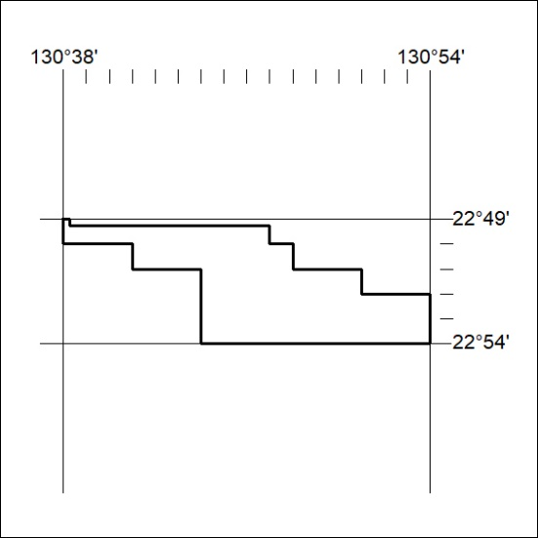
091/23

