Mineral Titles Act
NOTICE OF GRANT OF A MINERAL TITLE
Title Type and Number: | Extractive Mineral Permit 33078
Granted: | 24 March 2023, for a period of 5 Years
Area: | 52.13 Hectares
Locality: | AILERON
Name of Holder/s: | 100% ARAFURA NOLANS PROJECT PTY LTD* [ACN. 118 158 900]
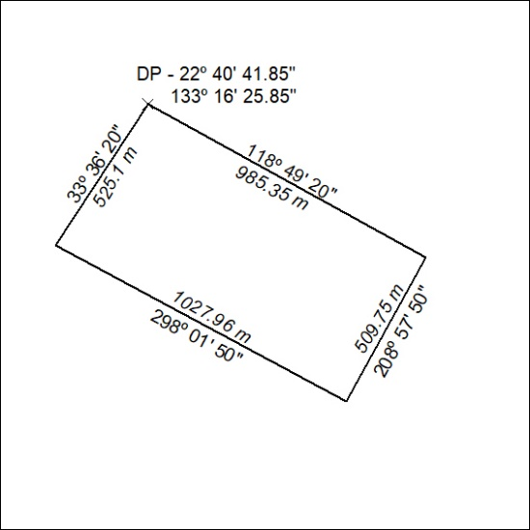

080/23

Mineral Titles Act
NOTICE OF GRANT OF A MINERAL TITLE
Title Type and Number: | Extractive Mineral Permit 33079
Granted: | 24 March 2023, for a period of 5 Years
Area: | 94.00 Hectares
Locality: | AILERON
Name of Holder/s: | 100% ARAFURA NOLANS PROJECT PTY LTD* [ACN. 118 158 900]
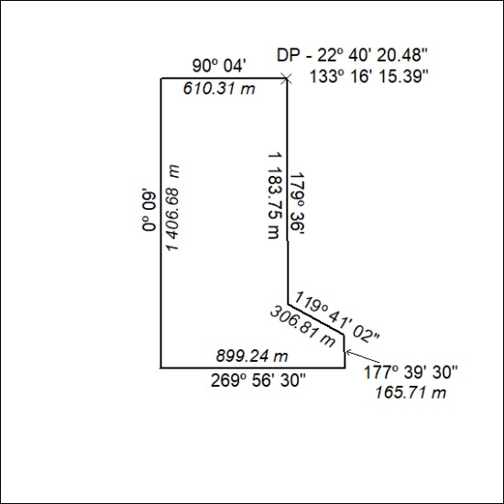

081/23

Mineral Titles Act
NOTICE OF GRANT OF A MINERAL TITLE
Title Type and Number: | Extractive Mineral Permit 33080
Granted: | 24 March 2023, for a period of 5 Years
Area: | 46.00 Hectares
Locality: | AILERON
Name of Holder/s: | 100% ARAFURA NOLANS PROJECT PTY LTD* [ACN. 118 158 900]
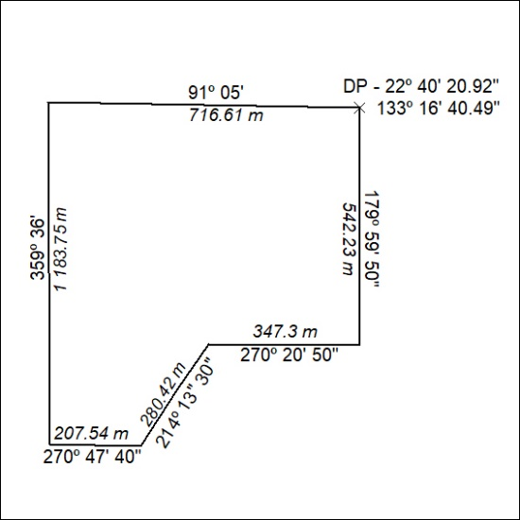

082/23

Mineral Titles Act
NOTICE OF GRANT OF A MINERAL TITLE
Title Type and Number: | Extractive Mineral Permit 33081
Granted: | 24 March 2023, for a period of 5 Years
Area: | 27.00 Hectares
Locality: | AILERON
Name of Holder/s: | 100% ARAFURA NOLANS PROJECT PTY LTD* [ACN. 118 158 900]
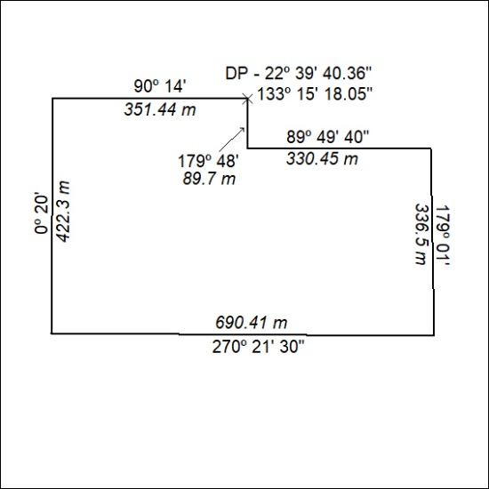

083/23

Mineral Titles Act
NOTICE OF GRANT OF A MINERAL TITLE
Title Type and Number: | Extractive Mineral Permit 33082
Granted: | 24 March 2023, for a period of 5 Years
Area: | 22.00 Hectares
Locality: | AILERON
Name of Holder/s: | 100% ARAFURA NOLANS PROJECT PTY LTD* [ACN. 118 158 900]
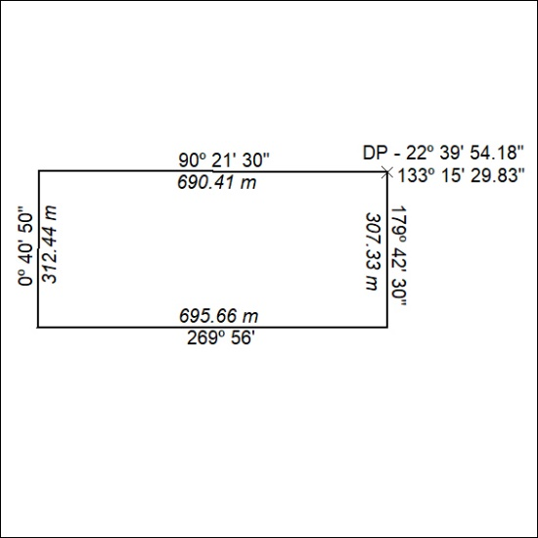

084/23

Mineral Titles Act
NOTICE OF GRANT OF A MINERAL TITLE
Title Type and Number: | Extractive Mineral Permit 33083
Granted: | 24 March 2023, for a period of 5 Years
Area: | 40.00 Hectares
Locality: | AILERON
Name of Holder/s: | 100% ARAFURA NOLANS PROJECT PTY LTD* [ACN. 118 158 900]
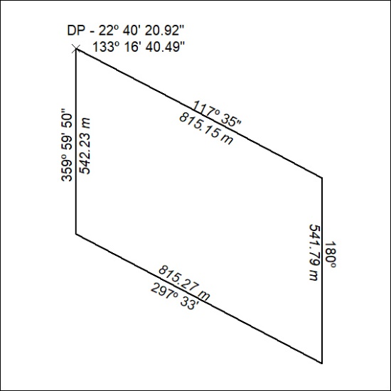

085/23

Mineral Titles Act
NOTICE OF GRANT OF A MINERAL TITLE
Title Type and Number: | Extractive Mineral Permit 33084
Granted: | 24 March 2023, for a period of 5 Years
Area: | 14.00 Hectares
Locality: | AILERON
Name of Holder/s: | 100% ARAFURA NOLANS PROJECT PTY LTD* [ACN. 118 158 900]
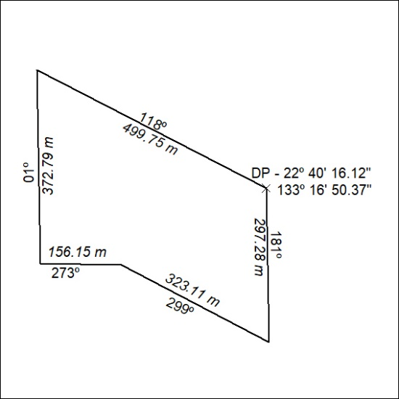

086/23

Mineral Titles Act
NOTICE OF GRANT OF A MINERAL TITLE
Title Type and Number: | Extractive Mineral Permit 33085
Granted: | 24 March 2023, for a period of 5 Years
Area: | 10.00 Hectares
Locality: | AILERON
Name of Holder/s: | 100% ARAFURA NOLANS PROJECT PTY LTD* [ACN. 118 158 900]
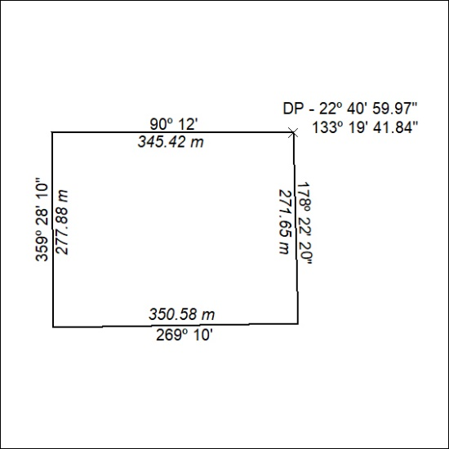

087/23

