Mineral Titles Act 2010
NOTICE OF LAND CEASING TO BE A MINERAL TITLE AREA
Title Type and Number: | Exploration Licence 31951
Area Ceased on: | 19 March 2023
Area: | 93 Blocks, 298.00 km²
Locality: | GEORGE CREEK
Name of Applicant(s)/Holder(s): | 100% MAGNET EXPLORATION PTY LTD [ACN. 623 568 918]
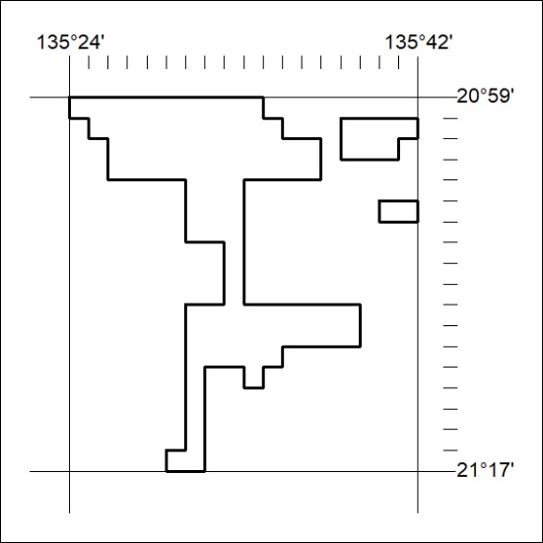

079/23

