Mineral Titles Act 2010
NOTICE OF LAND CEASING TO BE A MINERAL TITLE AREA
Title Type and Number: | Exploration Licence 32742
Area Ceased on: | 20 December 2022
Area: | 19 Blocks, 60.39 km²
Locality: | DOREEN
Name of Applicant(s)/Holder(s): | 100% ROCKTON RESOURCES LIMITED [ACN. 649 337 351]
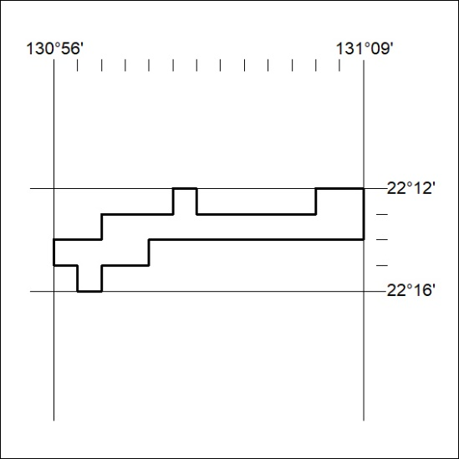

432/22

