African horse sickness

Information for horse owners

About the disease
African horse sickness is a serious viral disease of horses which is spread by biting midges. It can also affect donkeys, mules, and, less commonly, dogs and camels. There is no effective treatment or prevention for African horse sickness and up to 90% of horses who get the disease will die.
African horse sickness is exotic to Australia, however it has recently been detected in South East Asia, with Malaysia and Thailand reporting outbreaks of disease for the first time in 2020. Infected insects could come into Australia on wind currents.

Disease impacts
An outbreak of African horse sickness in Australia could have a major social and economic impact on individuals. It would disrupt the horse industry, which includes horse-racing and other equestrian activities.

Prevention activities
The national policy is to eradicate the disease if possible using quarantine and movement controls, vector control and destruction and disposal of infected animals.
There is no vaccine for African horse sickness currently available for use in Australia.

What to look for
Horses with African horse sickness usually become very sick suddenly, and will rapidly deteriorate and die. Some of the signs can include:
- swelling of the face and eyelids
- swelling of the head, neck and chest
- difficulty breathing, with or without frothy discharge from the nostrils
Signs in donkeys are generally mild.
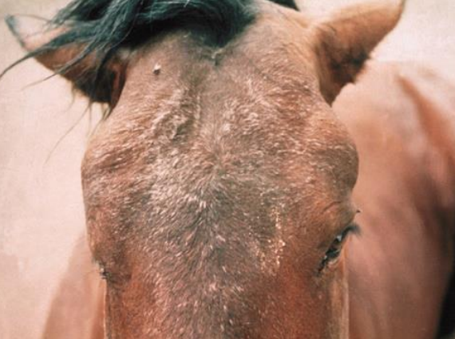 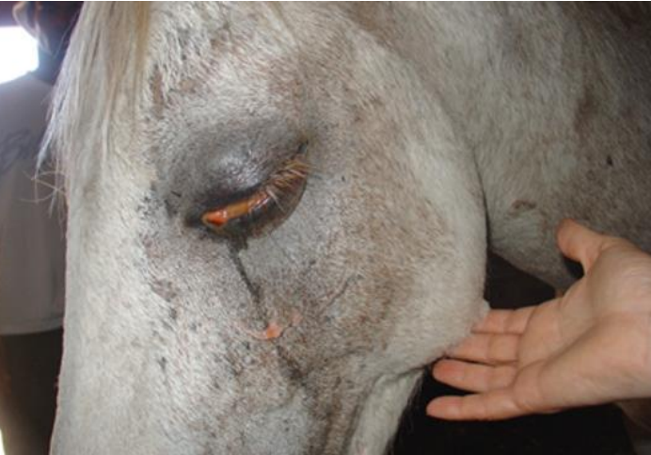
Swelling above the eyes. Source: OVI/ARC Swelling of the eyes and conjunctivitis. Source: Camilla Weyer, SAEPS]

What NT horse owners can do
- African horse sickness notifiable disease and any suspect case must be reported to the Chief Veterinary Officer.
- If you notice any severe illness or sudden death in horses, you should immediately contact your veterinarian or the Emergency Animal Disease (EAD) Watch hotline 1800 675 888.
- African horse sickness is diagnosed through blood tests taken by a veterinarian. Subsidies are available to cover the cost of veterinary investigations which rule out African horse sickness.
For more information contact your local biosecurity office:
Darwin 8999 2123
Katherine 8973 9716
Tennant Creek 8962 4458
Alice Springs 8951 8181

