Mineral Titles Act
NOTICE OF GRANT OF A MINERAL TITLE
Title Type and Number: | Exploration Licence 32226
Granted: | 11 May 2021, for a period of 6 Years
Area: | 248 Blocks, 813.56 km²
Locality: | BEETALOO
Name of Holder/s: | 100% BAUDIN RESOURCES PTY LTD [ACN. 618 455 593]
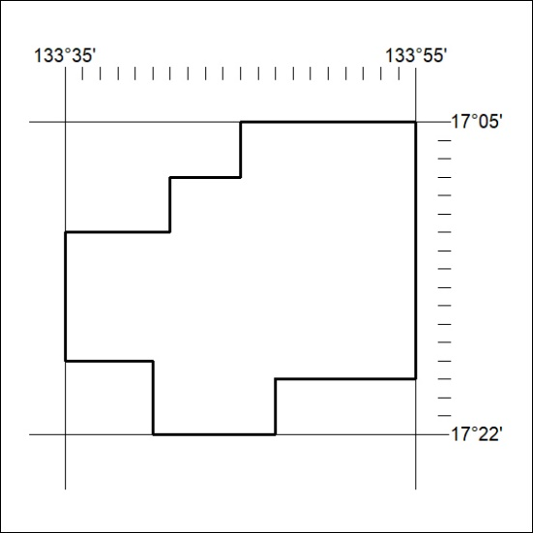
Area granted is indicated above. The titleholder is not permitted to exercise occupational rights on any land that is subject to a development title, or an application for a development title. Any land the subject of a Reserved Land gazettal under the Mineral Titles Act and all land vested in the Commonwealth of Australia is also excluded by description but not excised from the grant area.
154/21

Mineral Titles Act
NOTICE OF GRANT OF A MINERAL TITLE
Title Type and Number: | Exploration Licence 32329
Granted: | 11 May 2021, for a period of 6 Years
Area: | 42 Blocks, 136.99 km²
Locality: | HELEN
Name of Holder/s: | 100% BAUDIN RESOURCES PTY LTD [ACN. 618 455 593]
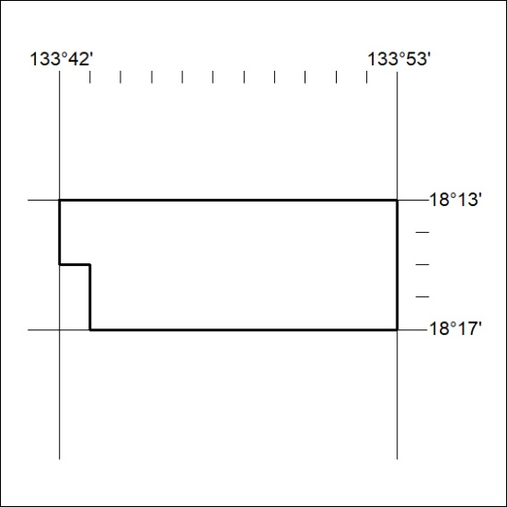
Area granted is indicated above. The titleholder is not permitted to exercise occupational rights on any land that is subject to a development title, or an application for a development title. Any land the subject of a Reserved Land gazettal under the Mineral Titles Act and all land vested in the Commonwealth of Australia is also excluded by description but not excised from the grant area.
155/21

Mineral Titles Act
NOTICE OF GRANT OF A MINERAL TITLE
Title Type and Number: | Exploration Licence 32437
Granted: | 11 May 2021, for a period of 6 Years
Area: | 184 Blocks, 601.11 km²
Locality: | UCHARONIDGE
Name of Holder/s: | 100% BAUDIN RESOURCES PTY LTD [ACN. 618 455 593]
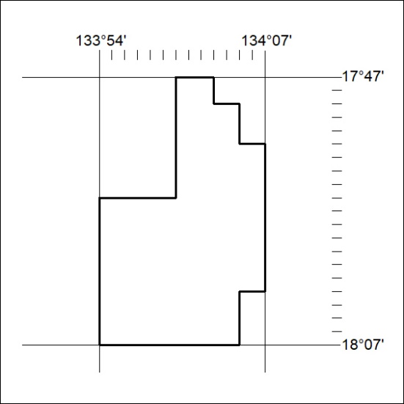
Area granted is indicated above. The titleholder is not permitted to exercise occupational rights on any land that is subject to a development title, or an application for a development title. Any land the subject of a Reserved Land gazettal under the Mineral Titles Act and all land vested in the Commonwealth of Australia is also excluded by description but not excised from the grant area.
156/21

Mineral Titles Act
NOTICE OF GRANT OF A MINERAL TITLE
Title Type and Number: | Exploration Licence 32491
Granted: | 11 May 2021, for a period of 6 Years
Area: | 6 Blocks, 20.06 km²
Locality: | McKINLAY RIVER
Name of Holder/s: | 100% ANICTOMATIS Ross
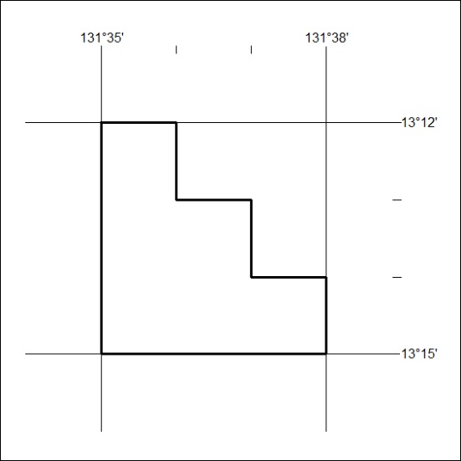
Area granted is indicated above. The titleholder is not permitted to exercise occupational rights on any land that is subject to a development title, or an application for a development title. Any land the subject of a Reserved Land gazettal under the Mineral Titles Act and all land vested in the Commonwealth of Australia is also excluded by description but not excised from the grant area.
157/21

Mineral Titles Act
NOTICE OF GRANT OF A MINERAL TITLE
Title Type and Number: | Exploration Licence 32505
Granted: | 11 May 2021, for a period of 6 Years
Area: | 186 Blocks, 561.02 km²
Locality: | FIELD RIVER
Name of Holder/s: | 100% PLUTONIC LIMITED [ACN. 632 991 167]
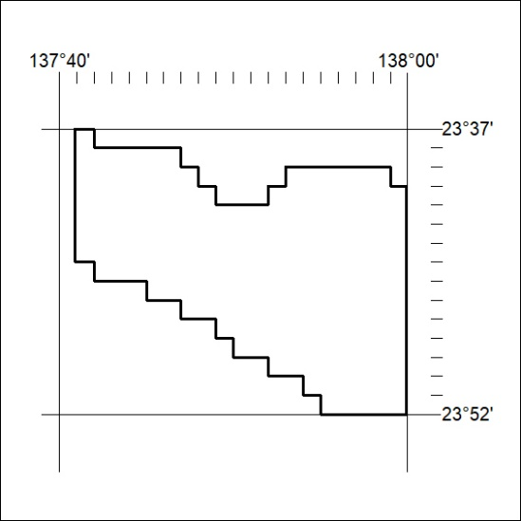
Area granted is indicated above. The titleholder is not permitted to exercise occupational rights on any land that is subject to a development title, or an application for a development title. Any land the subject of a Reserved Land gazettal under the Mineral Titles Act and all land vested in the Commonwealth of Australia is also excluded by description but not excised from the grant area.
158/21

