**Please read the following instructions prior to submitting drill core samples to the Northern Territory Geological Survey (NTGS) drill core facilities.**

*Prior arrangements must be made with the relevant core facility manager before delivery of any material to the core facilities*.

Core Facility Manager, Darwin

Department of Industry, Tourism and Trade

38 Farrell Crescent, Winnellie NT 0820

PO Box 4550 Darwin, NT 0801

Ph: +61 8 8984 3036

Email: [core.facility@nt.gov.au](mailto:core.facility@nt.gov.au)

Core Facility Manager Alice Springs

Department of Industry, Tourism and Trade

16 Power Street

Alice Springs NT, 0871.

Ph: +61 8 8951 8652

Email: [core.facility@nt.gov.au](mailto:core.facility@nt.gov.au)

# 1. Collection Policy

The NTGS drill core and cuttings collection aims to be representative of the geology of the Northern Territory; therefore, samples added to the collection are carefully selected.

With the exception of samples received under the Geophysics and Drilling Collaborations program, NTGS does not generally accept rotary drilling cuttings (RAB, RC, vacuum, air core) for selection.

For samples to be accepted, they must meet one or more of the following criteria:

1. contain important stratigraphic information
2. show representative styles of mineralisation
3. contribute to a representative suite for all major mineral deposits of the Northern Territory
4. are suitability intact to enable further geological studies
5. show outstanding examples of important geological features.

Submitted core must be ready for immediate cataloguing and storage within the collection. Therefore, all cutting and sampling for the submitting organisation’s work program must be completed **before** it is delivered to either of the NTGS Core Facilities.

# 2. Instructions to Operator

If one or more core samples have been selected for inclusion in the NTGS collection (as requested in communications from NTGS), make arrangements to deliver the core according to procedures described herein.

1. Complete one sample submission form for each drill hole.
2. After completing sample submission forms, please make contact with the relevant Core Facility Manager to give notice prior to shipment of samples.
3. Core/cuttings must be submitted to the Core Facility nearest to drilling site, either Darwin or Alice Springs.
4. Core must be delivered in standard commercial core trays in good and safe condition. Both Zincalume® metric trays (400 x 1000 mm) and plastic core trays are acceptable.
5. Core must be submitted in the correct size trays for the diameter of the core.
6. Trays must be labelled using a black Artline 400XF or equivalent black waterproof paint marker. Labelling must include hole name and core intervals.
7. Core containing radioactive material, or core from known uranium provinces, must have radiation levels tested and the measurements recorded in microSv/hr (µSv) above background.   
   Note: Radiation levels of all core will be checked upon receipt at the Core Facility.
8. The transportation of all materials submitted to the nominated core store, including costs, shall be the sole responsibility of the submitting company.
9. For submission of core drilled under the Geophysics and Drilling Collaborations program, at least half of all diamond drill core (ie split core cut length ways) from the entire length of the hole, must be submitted. Therefore, any analytical sampling, including petrography, must be taken from the Company’s half of the core.

## 2.1 Labelling

The submitting company must label the core trays before submission as described below and as illustrated in **Figures 1–3**.

### 2.1.1 Trays

On the top horizontal surface (left corner) of each tray, mark the starting depth of the cored interval. (**Figure 1**)

Example of how to label the trays

Figure 1 Label the starting depth of the cored interval on the top left corner of the tray

The exterior end of each tray must be clearly and accurately labelled as shown in **Figure 2**.

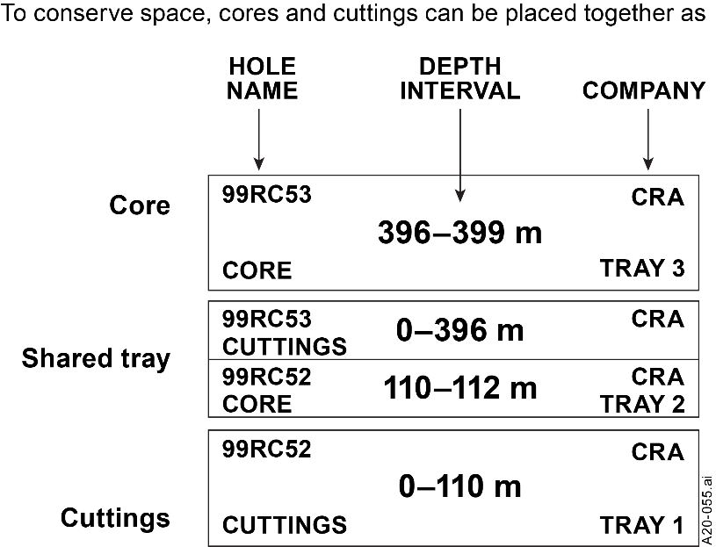

Figure 2 Exterior core tray labelling.

### 2.1.2 Core

Mark the core with one continuous orientation line with the full and half metres labelled between the lines (**Figure 3**). Note that the driller’s block reads from the same side as the core depth labels.

The block and all other labels should be legible from eye height when the core tray is on the ground.

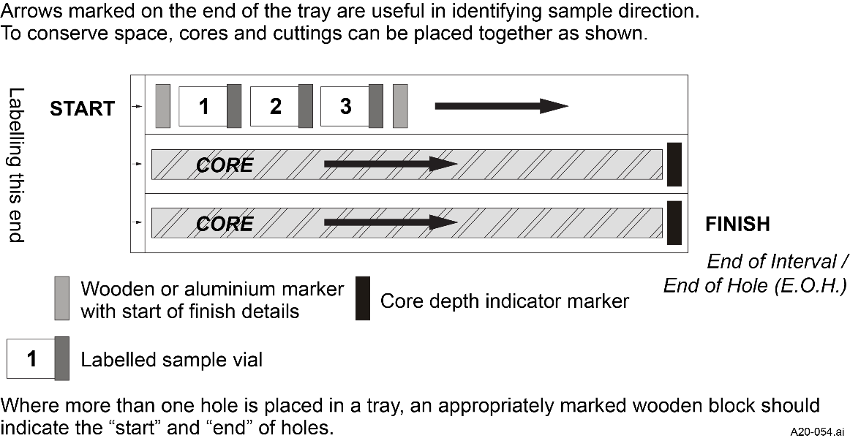

Figure 3 Core tray labelling.

### 2.1.3 Cuttings

For each representative depth interval, a sample of between 250 g and 500 g is required.

Samples must be contained within:

1. Mining grade UV stabilised, clear or foil bags, minimum thickness 150 µm, ~210 × 150 mm, labelled with the hole/sample name and depth using a black waterproof marker.
2. Standard plastic vials (~250 ml), labelled with the hole/sample number, and depth on both the vial and vial lid with a black waterproof marker.
3. All bags should have an aluminium tag also labelled with the hole/sample number and depth, stapled securely to the folded down top of the bag. The bags and aluminium tags should be labelled identically.

Plastic chip trays may be accepted, but only in addition to the minimum 250 g sample.

For co-funded Geophysics and Drilling Collaborations programs, in addition to the minimum 250 g sample, samples in chip trays for each metre down the hole will be required for the reverse-circulation drilling programs.

## 2.2 Other sample submissions

Other samples (e.g. rock samples, surface samples) can only be submitted by prior arrangement with the Core Facility Manager. They MUST be stacked and strapped in sequence on standard pallets.

## 2.3 Pallet layout and strapping

1. Core trays must be delivered on a standard pallet (AS:4068) of good condition.
2. Trays should be stacked in reverse sequential order and clearly labelled; that is, with the deepest tray first (Tray 21) up to shallowest tray on top (Tray 1). (**Figure 4**).
3. Lids must be fitted to top trays to prevent loss or damage of samples during transport.
4. Pallets must be secured with strapping 3 straps each side (**Figure 5**).
5. Pallets should not exceed 1 tonne in weight and should not exceed 1000 mm (1 metre) in height.

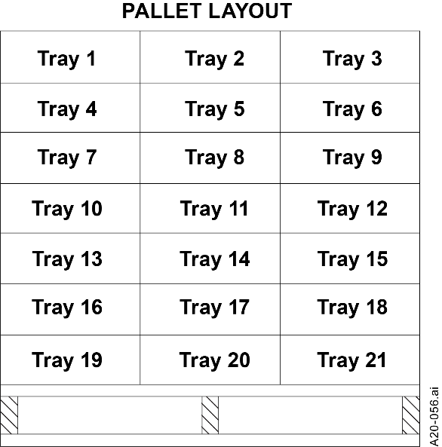

Figure 4 Stacking order.

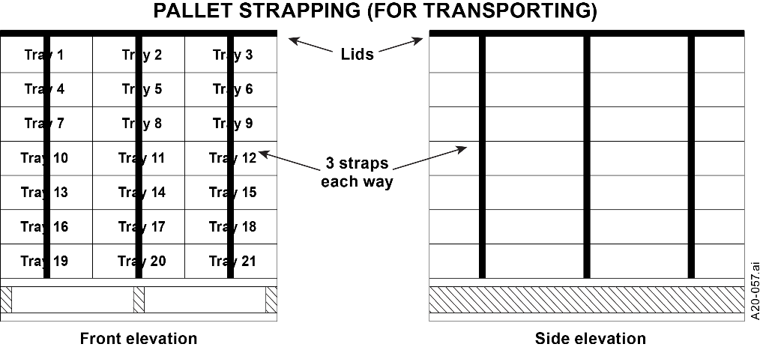

Figure 5 Pallet strapping for transport

## Acknowledgement:

Figures 1, 4 and 5 are based on figures produced by the Department of Energy and Mining, South Australia.